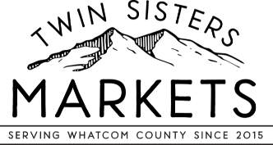
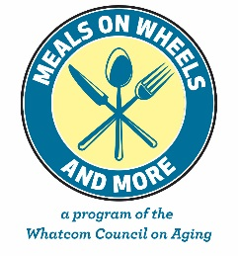
Voucher Range #_____________ to _____________
For office use only

2021 Twin Sisters Market Senior Food Voucher Program

*Name: *Birth Date: _

* Mailing Address: ________ _

* City: ______ Zip Code: _ * Phone #: ____________

The Twin Sisters Senior Food Voucher Program provides lower income seniors living in the Foothills region of Whatcom County and Birchwood/Alderwood Neighborhoods of Belligham with vouchers redeemable for edible food products at the Twin Sisters Markets (Birchwood, Nugent’s Corner and Kendall locations).

To be eligible for the Twin Sisters Senior Farmers Market Vouchers, you must meet all of the following:

* You are 60 years old or older (or 55+ if you are Native American /Alaska Native)

* You consider yourself to be low income.

* You are a resident of Whatcom County, WA.

By signing this form, you certify that you meet all the eligibility requirements above.

*
Participant Signature Date

Please answer the two questions below:
- Did you receive the WA State Senior Farmers Market Coupons this year? __Yes __ No

- Where do you shop for most of your groceries? ________________________________

The Twin Sisters Market Food Voucher Program is a partnership between the Whatcom Council on Aging and the Twin Sisters Market and is not affiliated with the Washington State Senior Farmers Market Nutrition Program. Vouchers are only good for edible food at the Twin Sisters Market through 10/31/21.

The Whatcom Council on Aging does not discriminate on the basis of sex, race, creed, religion, color, national origin, age, veteran or military status, sexual orientation, disability, or the use of a dog guide or trained service animal. (RCW 49.60.030)

Return application to: the Twin Sisters Market, the Foothills Foodbank, EWRRC, or Meals on Wheels and More: 315 Halleck Street, Bellingham, WA 98225; Fax: 360-647-7952; jmeyers@whatcomcoa.org.

